 &  
Good News to the Ghentiles

22 County Route 22
Ghent, NY 12075

518-828-5946 Office
Office hours by appointment
Office Administrator: 518-828-6425 (home)

www.ghentreformed.org
Ghent.Ref.Church@gmail.com

CONSISTORY:
Pastor: Open
Contract Elder: Bonnie Pflegl, eff. 8/1/21
Consistory VP: Richard Leggett, Sr.
Consistory Clerk: Roberta Keller
Elders: Peter Schertel, Dick Leggett
Robbie Keller, Beth Colwell
Deacons: Bootie Fenoff, Dan Jones, Nicolas Tipple, Cindy Rivenburgh
Treasurer: Richard Leggett, Jr.
Sexton: Penny Schertel
Office Adm: Bonnie Pflegl
Sunday School: Robbie Keller, Penny Schertel

COMMITTEES:
Worship: Peter Schertel, Beth Colwell
Nurture: Cindy Rivenburgh, Robbie Keller
Stewardship/Mission: Bootie Fenoff, Dan Jones
Property: Dick Leggett, Nick Tipple
Search: Open

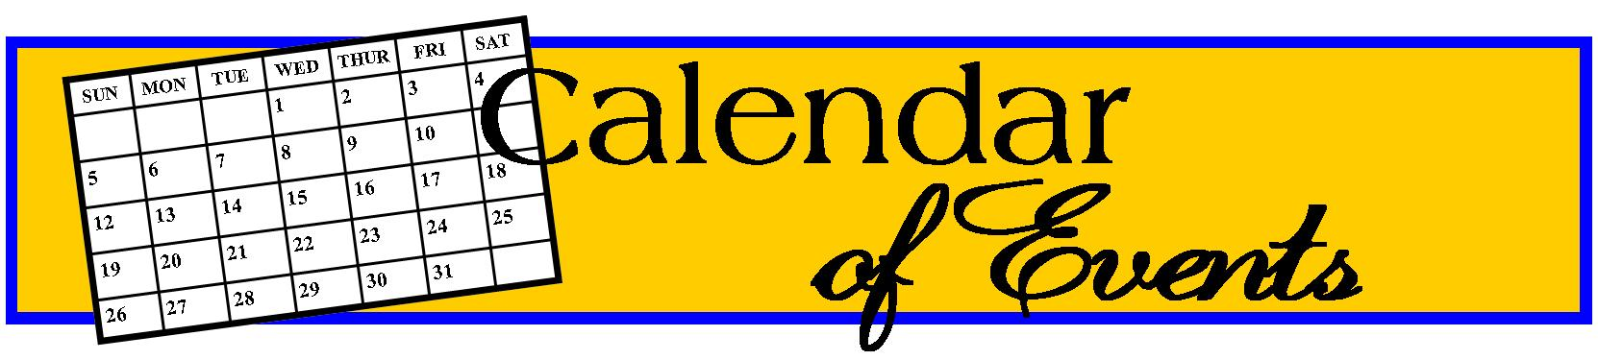

5/4 Ghent/Chatham Seniors 1pm
5/4 Covid clinic @ Church 1-3pm
5/8 MOTHER’S DAY
5/15 Sunday School Prog./Covered Dish
5/17 Cancer Support Group 5:30pm
5/18 Game Night 5:30pm
5/20 WWD 11:30pm
5/30 MEMORIAL DAY
6/1 Ghent Chatham Seniors 1pm
6/5 Installation of new Consistory and
Reception of new members 8:30am
6/12 Consistory 10:15am
6/15 Game Night 5:30pm
6/17 WWD 11:30am
6/19 FATHER’S DAY
6/21 Cancer Support Group 5:30pm
6/22 Game Night 5:30pm

CONSISTORY UPDATES:
There is still one person needed to fill our Consistory. Installation will be on June 5.

Any questions or comments, don’t hesitate to leave Bonnie a message or contact one of the Consistory members listed.



BIRTHDAYS & ANNIVERSARIES
MAY
2 STEVE MASHAW
3 AUDREY PITT COON
LIZ GRATTAN
8 OLIVIA PREUSSER
11 BOOTIE FENOFF
13 BERT POUCHER
15 STAN BURCH
16 LESTER OGDEN, JR.
HEIDI HOWARD
17 JIM ANDREWS
21 BRUCE & CINDY TIPPLE
25 WALLY & NANCY RANFT
26 JUDY DONNELLY
28 ADDISON ANDREWS
31 STEPHEN LEGGETT

JUNE
1 LARRY & NORA VAN BRUNT
7 WALLY RANFT
8 SALLY CHARRON
11 RICK & KAREN LEGGETT
12 RICK LEGGETT GEORGE & JUDY DONNELLY
19 BETTY BEDNAR
21 ED & BEV COON
22 JEFF & LEAH PRACK
23 KAITLYN BURCH
25 BERT & STEPHANIE POUCHER
27 KENT & ROBBIE KELLER
30 LESTER & RUTH OGDEN

CANCER SUPPORT
The Cancer Support group meet in our fellowship hall on the third Tuesday of each month.

Bootie is still collecting dimes to help support those who have a financial need as they, and their families, deal with cancer issues. She’s also collecting clean wine bottles (no corks or tops) for the VFW.

SUNDAY SCHOOL
The Sunday School program for this year will close on Sunday, May 15th. After their presentation and service, we will have a covered dish celebration.



HIS LOVING HANDS
The mission for May and June will be the collection of socks, t-shirts and personal care items for veterans.

Local men and women have served this country for us, but some have returned home and are now in need of our help to sustain their living.


GAME NIGHTS
Come have some fun, laughter and snacks on Wednesdays: May 18th and June 15th at 5:30pm. Penny and Bootie keep us laugh-ing and challenged. All are welcome. If you spontaneously decide to join us, don’t worry about a snack. There’s always plenty.


WELCOME SENIORS
The Ghent-Chatham Seniors are using our education wing for their monthly meetings. We are happy to have them here. They meet the first Wednesday of the month at 1pm. If you have any questions or would like to join, please contact Bootie Fenoff at 518-392-4805.

COVID BOOSTERS
If you would like a second booster shot for COVID, come to the Church sanctuary on Wednesday May 4th from 1-3pm. The Department of Health will be there.

Additionally, they will have all previous vaccines available, in you need one of them.

NOMINATING COMMITTEE
The committee is still looking for a Deacon to fill the 4 spots that are open on Con-sistory. Although I’m sure they have contacted everyone, perhaps they missed you or you are having second thoughts. Please contact Kim Meade, George Bednar or Rick Leggett if you can help in this matter. Thank you.
BIBLE STUDY
It has been requested that an adult Bible study be started. I have had a few people say they would like to participate, but we’re sure there are a few more that would like to be there. Please let Bonnie know if you are interested.

Possible times would be during the day, probably a Saturday or after Church on Sunday. If the majority prefer a night time, Bonnie will pick up, and take home, all who would not be able to get to the Church at night. It hasn’t been determined how often we will meet.

At present, no theme has been identified, but we’re hoping that leaders of the study can rotate so that this isn’t the job of just one person.


RECEPTION OF NEW MEMBERS
Gloria Clevenger, Audrey Coon and Joanne Mink have been studying what it means be a member of the Reformed Church of America and more specifically, what their faith is and how they fit into our Church.

On Sunday, June 5th at 8:30am, with the assistance of Rev. Visser, we will be able to receive them as members of our Church.

Hopefully, at the same time, we will be installing and/or ordaining new members to the Consistory.

Please join us for regular service afterward, along with a small reception.

CAMP FOWLER SCHOLARSHIP
It’s that time again to think about fresh air and communing with God at Camp Fowler in Speculator. This year they have a Tier system for each week. A week’s stay is $475 to $710.

If you have a child(ren) that would like to go to camp, please have them write the Consistory a note by June 10th stating why they’d like to go. They will be reviewed at our meeting on June 13th. This year we are able to issue full scholarships in the amount of $475 per child of a member of our congregation. If they have a friend that they would like to attend with, we will be able to give them a scholarship of $225.

Some of the weeks are already full and working off of a wait list. If you are interested in having your child attend camp, go to their web site ASAP to get registered. (campfowler.org)

A CHANGE!
You may not know, but postage is going up effective July 10, 2022. The first-class regular mail will be $.60, an increase of 2 cents. If you have to pay for another ounce, it will be $.24, an additional 4 cents.

So in an attempt to cut the cost of our mailing, we’re going to try emailing the newsletter to you. (It comes in color!)

Please let me know your email address if you want to receive the newsletter.
MEMORIAL DAY
We remember more than 150 years ago, Memorial Day took shape amid the backdrop of the U.S. Civil War. Before it ended, women began decorating the graves of fallen soldiers.

In 1868, when May 30 was designated as Decoration Day, loved ones placed flowers on the graves of Union and Confederate soldiers alike. By 1882, Decoration Day became known as Memorial Day, and soldiers who died in other wars were honored too.

Over time, it became a day to remember all loved ones who have died — in war and otherwise.

In 1971, Congress declared Memorial Day a national holiday to be observed on the last Monday in May. On Memorial Day, we pause to remember people who made the ultimate sacrifice for their country and for our freedom. We also pray for those who continue serving, especially those in harm’s way.

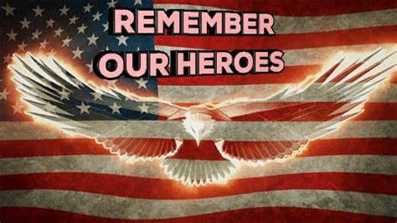

MOTHER’S DAY QUOTES
“There is no way to be a perfect mother, and a million ways to be a good one.”
—Jill Churchill

“The art of mothering is to teach the art of living to children.” —Elaine Heffner

“An ounce of mother is worth a ton of priest.” — Spanish proverb

“When your mother asks, ‘Do you want a piece of advice?’ it’s a mere formality. It doesn’t matter if you answer yes or no. You’re going to get it anyway.”
— Erma Bombeck
(I so love her outlook on life!)

“The mother’s heart is the child’s schoolroom.” — Henry Ward Beecher

“Mother love is the fuel that enables a normal human being to do the impossible.”
—Marion C. Garretty

“Being a mother is learning about strengths you didn’t know you had.”
—Linda Wooten

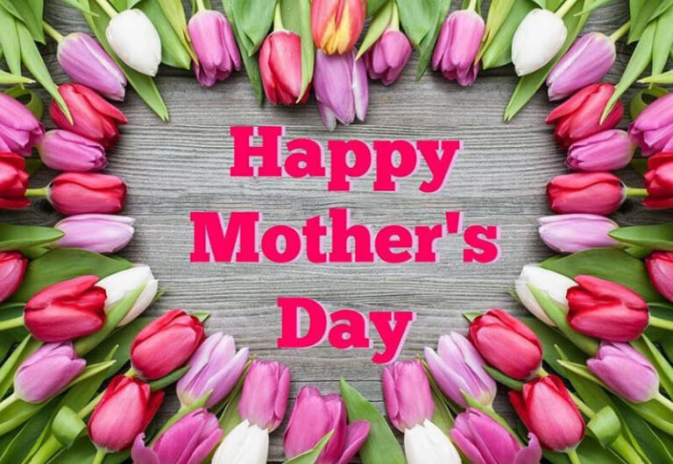

FATHER’S DAY QUOTES
*“I believe the heart of the heavenly Father is reflected in the heart of the earthly father.” – Nathan Lorick
*“It is admirable for a man to take his son fishing, but there is a special place in heaven for the father who takes his daughter shopping.” – John Sinor
*“My dad taught me that good health is all about living in gratitude.”
– Marishka Hargitay
*“My father gave me the greatest gift anyone could give another person: He believed in me.” – Jim Valvano
*“No matter what drama I deal with at work, when I get home and hear them scream, ‘Daddy!’ I forget whatever it was I was stressed about,” – Mario Lopez
*“Any man can be a father, but it takes someone special to be a dad.”
— Anne Geddes
*“Dads are like chocolate chip cookies; they may have chips or be totally nutty, but they are sweet and make the world a better place.” – Hillary Lytle
*“My father, he was like the rock, the guy you went to with every problem.”
– Gwyneth Paltrow
*“My dad, like any coach, has always stressed the fundamentals. He taught me responsibility, accountability, and the importance of hard work.” – Steve Young
*“My father didn’t do anything unusual. He only did what dads are supposed to do—be there.” — Max Lucado
*“Dad, you’re someone to look up to no matter how tall I’ve grown.” – Anon
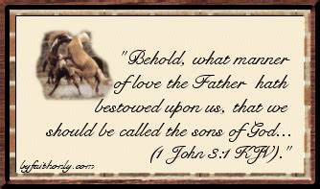

REFLECTIONS by Bonnie

“We are not here to be successful. We are here to be faithful.” —Mother Teresa
Give and take Life is often a matter of giving and taking. But with what spirit do we give — or take? The British author, Elizabeth Bibesco, once said, “Blessed are those who can give without remembering and take without forgetting.” Accomplishing that will require some practice, won’t it? Giving something to another person or to God’s church, and not remembering the act may go against our nature. Yet, when we can give without remem-bering or without begrudging what we gave, the giving can become habitual and instill a feeling of joy. So, try to remember the happiness of giving, but forget the occasion of doing so. On the other hand, most of us are recipients of gifts given and good deeds done by others. Remember with gratitude those blessings. Savor the joy they aroused in us and be grateful for the givers. Give without remembering. Take without forgetting. Those are clues to better living. (Copied from the Linlithgo Lantern)

The first thing that caught my eye from Linlithgo’s newsletter was the quote from Mother Teresa. Most of our life we have been pushed to be successful. Walking before the age of 1, potty training before the age of 2, being the smartest in the class, most popular, best job, happy marriage, beautiful house and wonderful offspring. We, and/or our parents, have spent a lot of time trying to accomplish these feats. But my question is, have we invested as much time into being faithful?

I’m sure that we have all prayed for guidance and assistance along our pathway to a successful life, and have probably expressed our thanks to our God when wonderful things have happened to and for us. However, I don’t think that’s what Mother Teresa is trying to get through to us. Her unconditional faith led her to impoverished peoples and poor living conditions for herself. We, who live here in Columbia County, don’t have the same trials and faith moments that she experienced. However, I do believe that we have a faith that is powerful, even though we sometimes don’t bring it to the forefront of our thoughts and lives.

The quote from the British author, Elizabeth Bibesco, “Blessed are those who can give without remembering and take without forgetting” I find equally noteworthy. My quote in my High School yearbook was “I give what I can, receive what I must.” I have had to learn, and it’s still hard for me, to receive without putting up a fuss or trying to pay it back. It’s very hard for me to just say thank you.

I have found it equally hard to accept Christ’s death on the cross for my (our) sins. Why did He do it? I don’t deserve it! I can’t pay it back!!! I don’t want to take something so wonderful without paying. As I said, I struggle.

However, that is what grace is all about. This is where faith comes in, even as little as a mustard seed. I will never have the faithfulness of Mother Teresa, but I know that I have been given a gift that I will remember all the rest of my life, in faith.

